Natural capital and biodiversity net gain at Liverpool Waters
A natural capital and ecosystem services assessment and valuation has been completed for Liverpool Waters, a major development on the east bank of the River Mersey in the centre of Liverpool. Liverpool Waters is a five neighbourhood, business and residential development being built on 60 hectares of reclaimed and former dock land. Due to the size of the development it has been phased over a 30-year construction period, which commenced in 2012 and is due to be complete in 2041.
The principles of natural capital and ecosystem services are central to the UK Government’s 25-year Environment Plan, from which biodiversity net gain is to become mandatory, and environmental net gain to follow in the future. The concept has also been adopted by the Liverpool City Region to help meet strategies around air pollution reduction, meeting the Carbon Neutral City target by 2040, and to enhance economic and social well-being. | What is natural capital?  Natural capital (the stock of natural assets e.g. soils, water, biodiversity) produces a wide range of ecosystem services that provide benefits (e.g. food production, carbon sequestration, regulation of flooding and water quality, air pollution regulation, recreation, physical health and well-being) to people.
Approach
Ecosystem service modelling, monetary valuation and biodiversity assessment were applied to the Liverpool Waters site before the development began in 2006 (baseline) and to the masterplan for the development, to see if natural capital and biodiversity net gain could be achieved. Natural capital was mapped for the baseline and masterplan, then the capacity of the natural environment to deliver 8 different ecosystem services was modelled and mapped at high resolution across the site (carbon storage, carbon sequestration, air quality regulation, climate regulation, noise regulation, water flow, water quality, and accessible nature). The demand for air quality regulation, noise regulation, and climate regulation services was also mapped. A further 4 services were quantified but not mapped (timber production, water recreation, physical health and well-being). All of these, including carbon sequestration, and air quality regulation were assigned a monetary value.
Results
The Liverpool Waters baseline showed a reasonable provision of local climate regulation, water flow and water quality services (see Table 1), but a low provision for all other services. The only service with any notable value was water recreation (present value £1.2 million over 50 years). The demand maps for local climate regulation, noise regulation and air pollution regulation all demonstrated a high demand for these services in the 1.5 km² area of Liverpool city centre around Liverpool Waters. The biodiversity assessment showed a relatively low baseline quality of 16.45 biodiversity units.  Under the proposed masterplan, there has been an increase in the quality of habitats incorporated into the site (woodland, street trees, perennials, etc.), and provision of green space in the form of a 2-hectare public park for access to recreational opportunities. Eight out of the twelve ecosystem services assessed increased (Table 1). These are carbon storage and sequestration, timber production, air quality regulation, water quality, access to nature, physical and mental health. | Table 1. Direction of ecosystem services provision and biodiversity from baseline to masterplan at Liverpool Waters.  Ecosystem service / biodiversity Baseline Masterplan Direction of change  Scores 0-100  Carbon storage 0.5 2.76  Carbon sequestration 0 1.6  Local climate regulation 41.5 39.3  Air quality regulation 0.1 0.87  Noise regulation 3.6 2.1  Water flow 36.9 34.3  Water quality 47.2 52.7  Accessible nature 0 20.9  Annual physical flows  Timber production 0m³ 4.14 m³  Water recreation - -  Physical health 0 active visits 6709 active visits  Mental health 0 visits 3,516,367 visits  Biodiversity units  Biodiversity 16.45 9.52

Carbon sequestration increased by 5 tonnes/CO₂e/yr (Map 1), and therefore by £20,000 in present value over 50 years, the regulation of PM_{2.5} has increased by 0.03 tonnes/yr, with an increase of £375,000 in the present value over 50 years. By far the most valuable services are physical health and wellbeing, due to the provision of green space, increasing the present value from 0 to £169.2 million and £1.1 billion over 50 years, respectively.

Map 1(a) Carbon sequestration (b) air quality regulation (PM_{2.5}) Liverpool waters baseline (left) and masterplan (right)
(a)  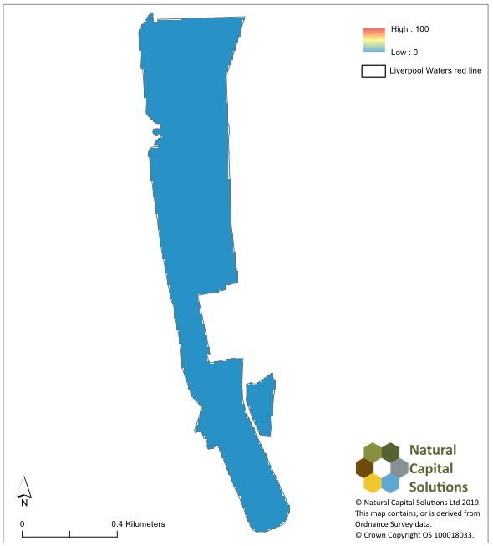 | 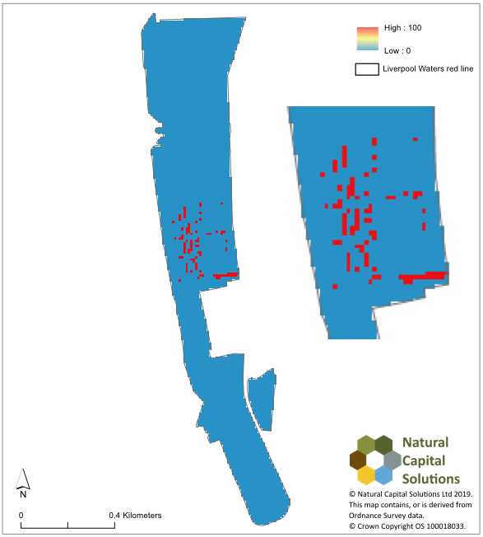
(b)  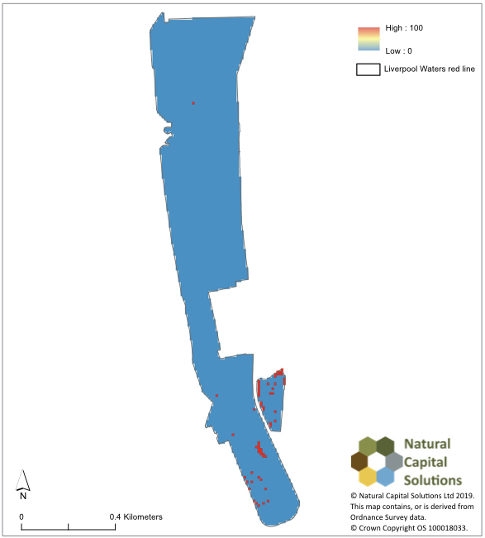 | 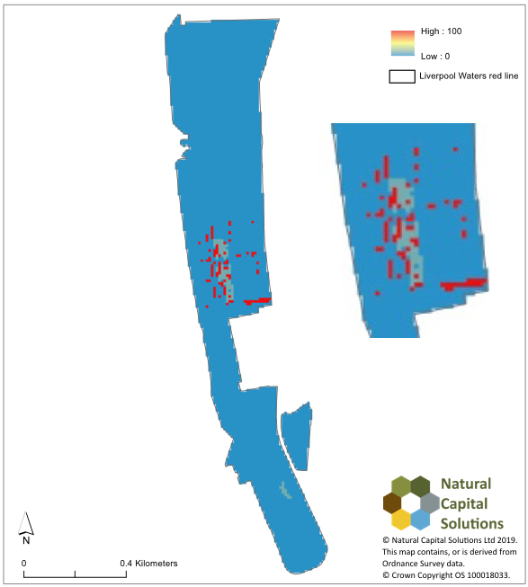
Conclusions and recommendations
The results demonstrate that the Liverpool Waters development will achieve net gain in ecosystem services provision across the services that could be quantified (recreation could not be accounted for here, so the value of the services provided is in reality likely to be higher). Taken together the Liverpool Waters development delivers an additional £34.4 million of public benefits annually, with a present value of £1.3 billion over 50 years compared to the baseline.
Unfortunately, the masterplan does not achieve biodiversity net gain at the site in its current design (9.52 biodiversity units for the masterplan, a change of -6.93). If the Central Docks neighbourhood is taken in isolation, this area is not far from no net loss.

